**TASK1**

Task : /**/** Nested array data for customers - details Id, name, place, email, amount

const customerData = [

[3000, 'John Doe', 'New York', 'john.doe@email.com', 1000],

[3001, 'Alice Smith', 'Los Angeles', 'alice.smith@email.com', 1200],

[3002, 'Bob Johnson', 'Chicago', 'bob.johnson@email.com', 800],

[3003, 'Emily Davis', 'San Francisco', 'emily.davis@email.com', 1500],

[3004, 'David Lee', 'Houston', 'david.lee@email.com', 1100],

[3005, 'Sophia Chen', 'Miami', 'sophia.chen@email.com', 900],

[3006, 'Michael Wilson', 'Seattle', 'michael.wilson@email.com', 1300],

[3007, 'Emma Brown', 'Dallas', 'emma.brown@email.com', 950],

[3008, 'Daniel Miller', 'Boston', 'daniel.miller@email.com', 1050],

];

// Questions for the customer data

// 1. Print the names of all customers.

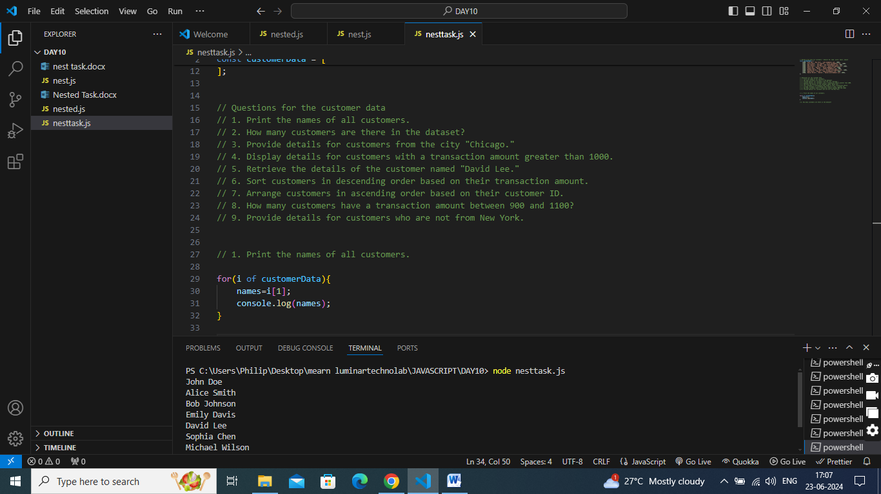

// 2. How many customers are there in the dataset?

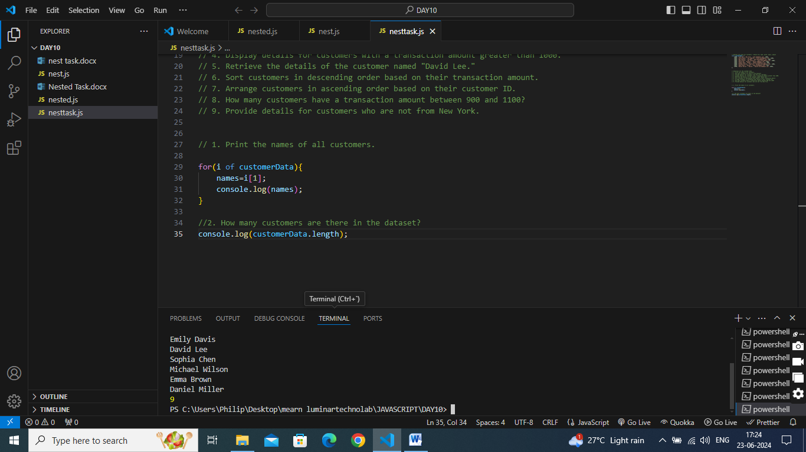

// 3. Provide details for customers from the city "Chicago."

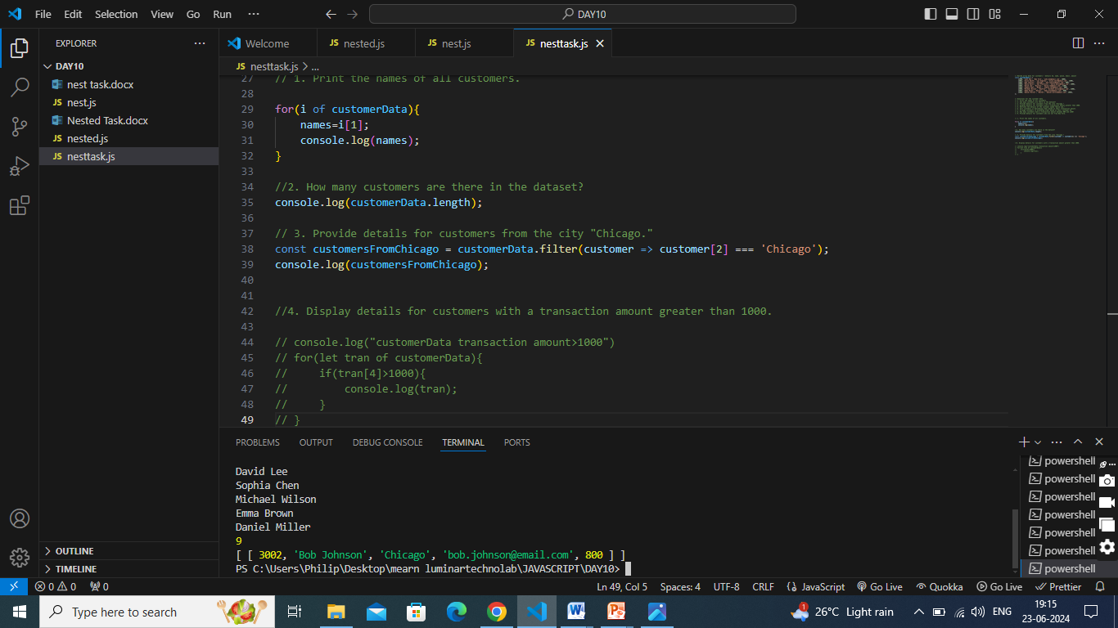

// 4. Display details for customers with a transaction amount greater than 1000.

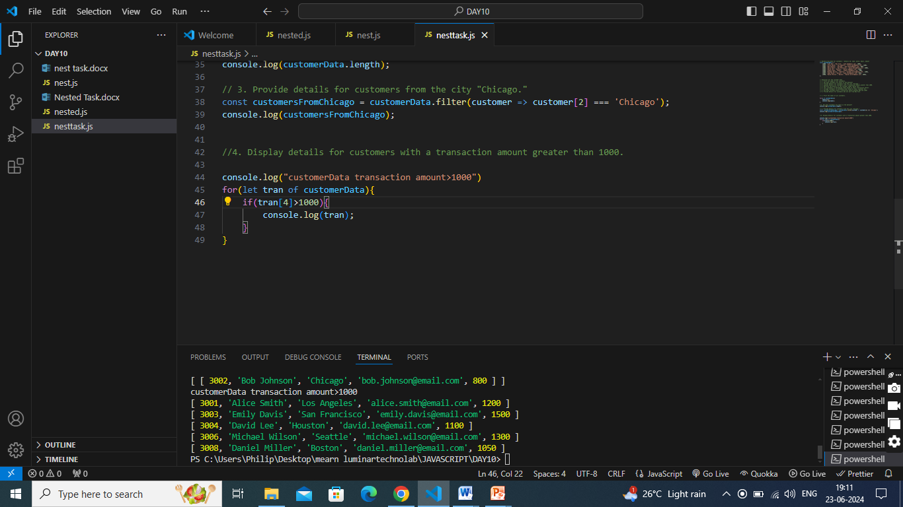

// 5. Retrieve the details of the customer named "David Lee."

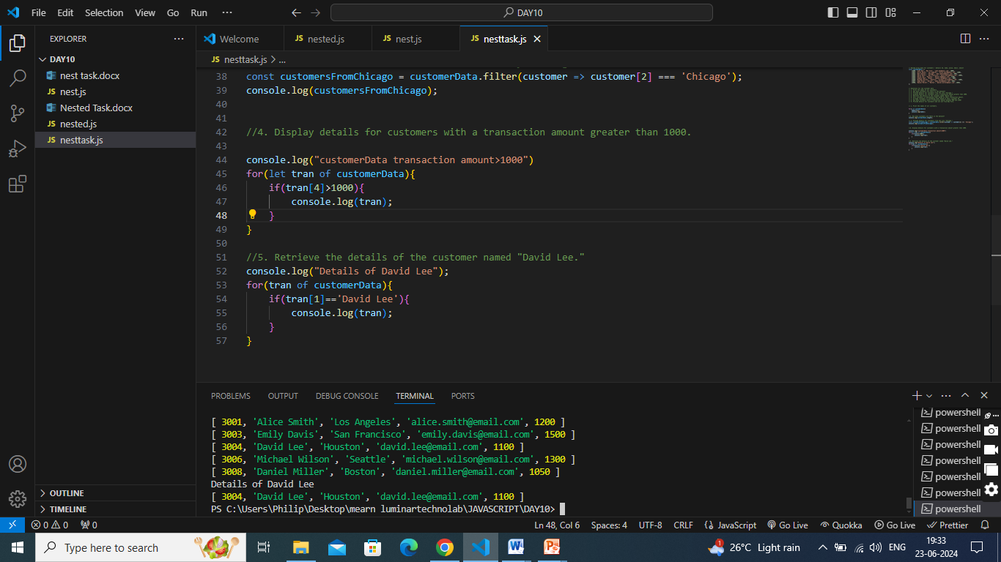

// 6. Sort customers in descending order based on their transaction amount.

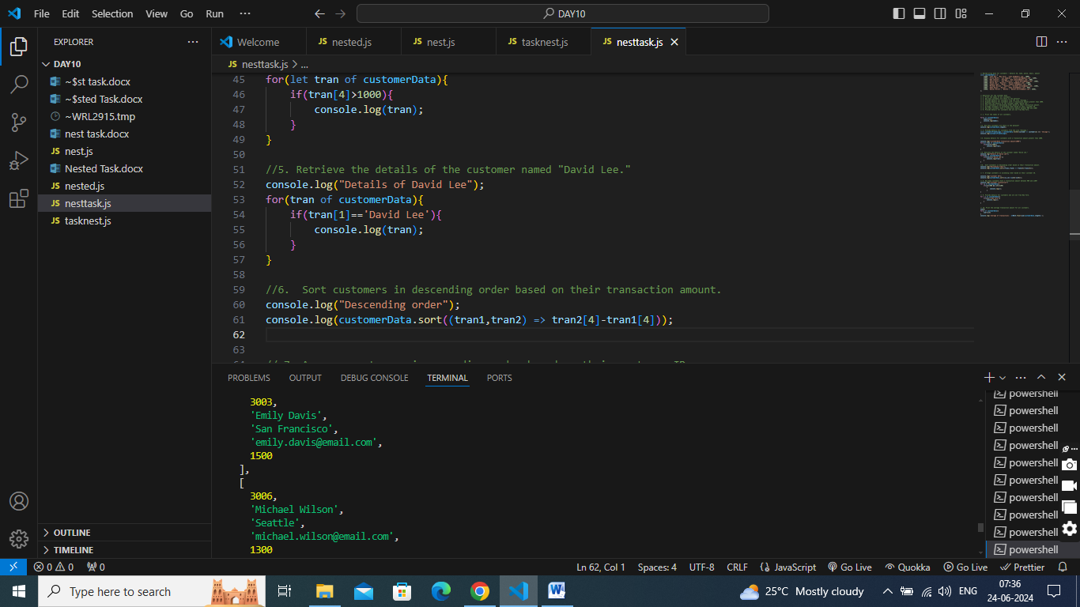

// 7. Arrange customers in ascending order based on their customer ID.

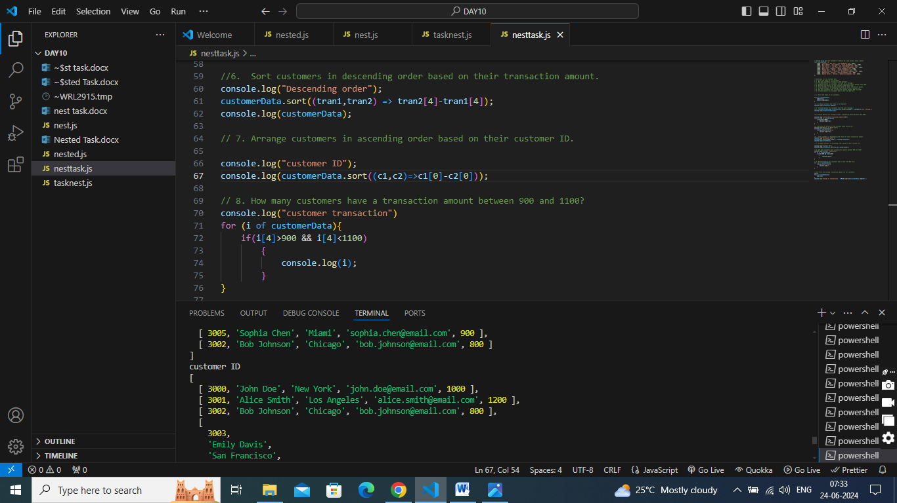

// 8. How many customers have a transaction amount between 900 and 1100?

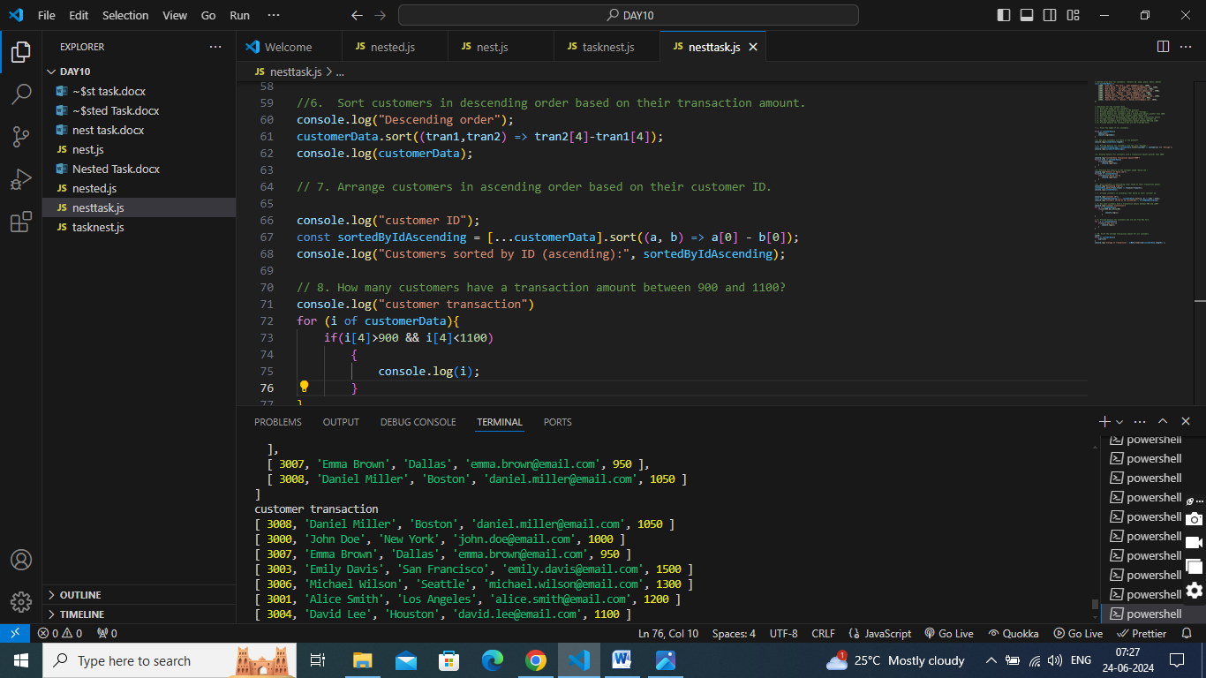

// 9. Provide details for customers who are not from New York.

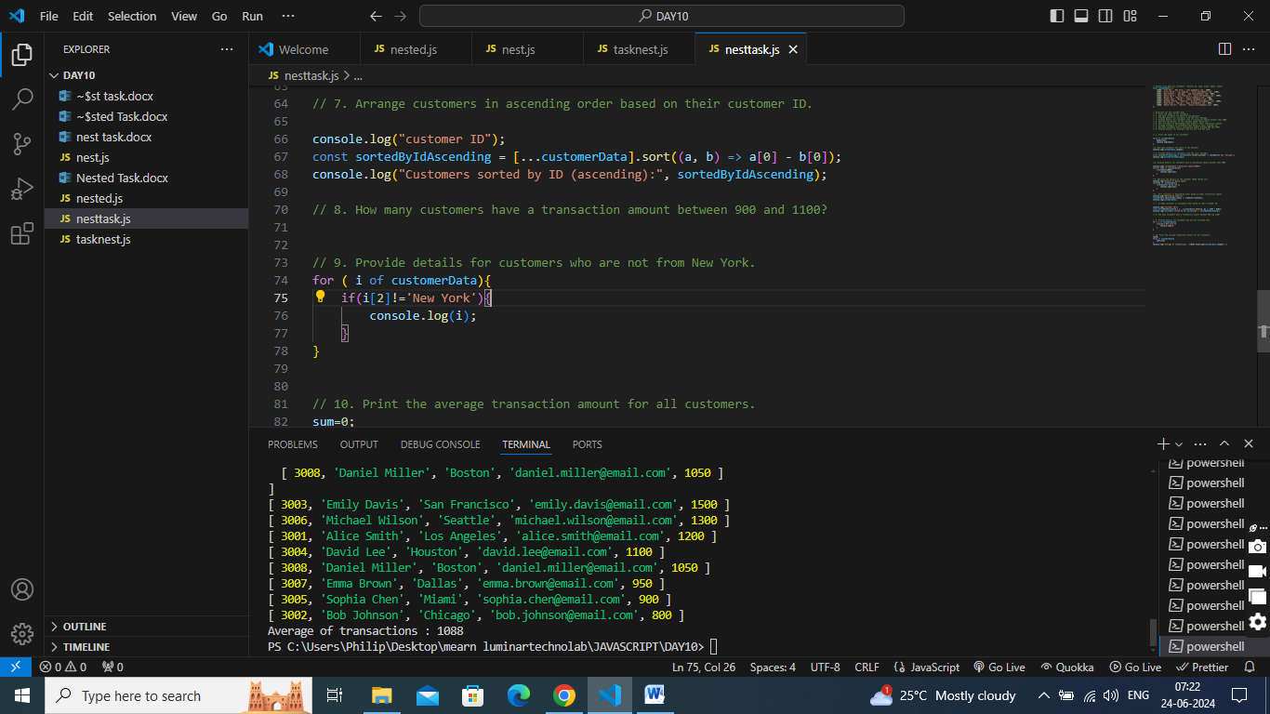

// 10. Print the average transaction amount for all customers.

